https://www.youtube.com/watch?v=aBtMvQdb3vs
Domain-Driven Design

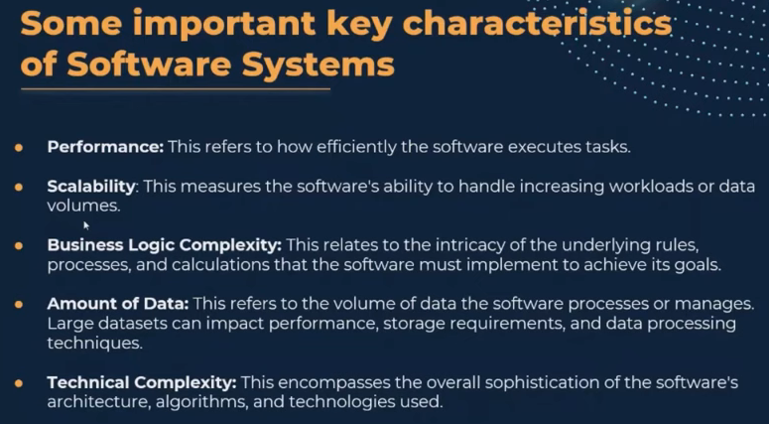

When to apply DDD
- Business logic complexity
- No domain knowledge
- App feature changes often

When not to apply
- Simple domain
- CRUD based applications
- 30-40 use cases

DDD is not a design pattern , architecture pattern , technology

- Everyone speaks the same language (dev & BA’s)
- Business language is same as coding language
- A software development approach
- Business people help to achieve a better design and developers help to understand business better
- Strategic and tactical pattern

Strategic pattern
- DDD strategic patterns are bule prints for structuring and organizing complex software systems aligned with business domains.

Ubiquitos language
- Valid only inside a given bounded context
- Helps to create valuable business domain models
- Serves a design

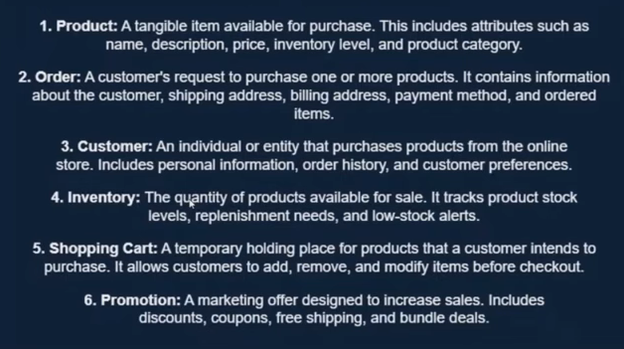
https://www.youtube.com/watch?v=o-ym035R1eY

Strategic design : at higher level
Tactical design : at lower level – closer to the code

Strategic design , we talk about the problem not the solution .

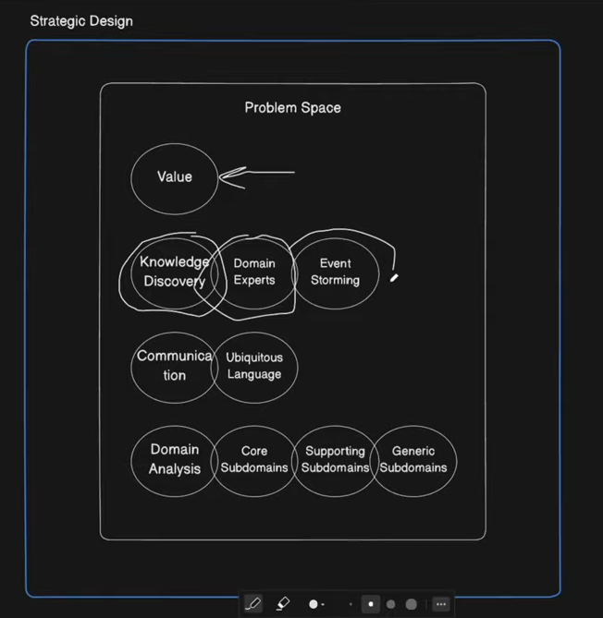

- Knowledge discovery
- Domain experts
- Event storming
- Communication
- Ubiquitous language
- Domain analysis , Core Subdomains , Supporting subdomains , Generic subdomains

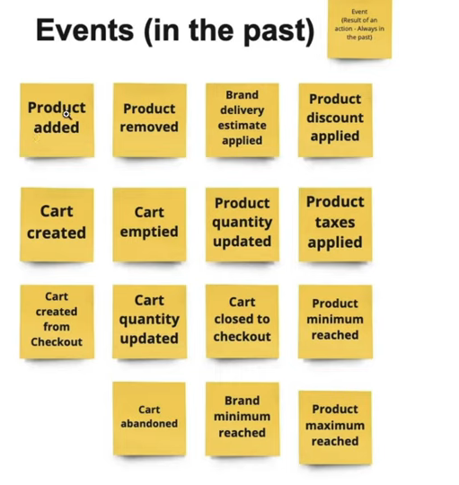

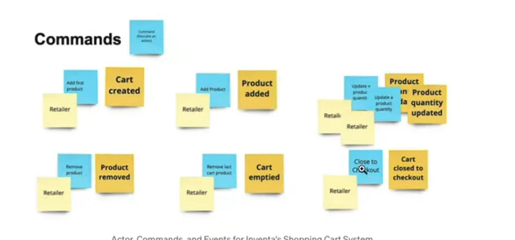

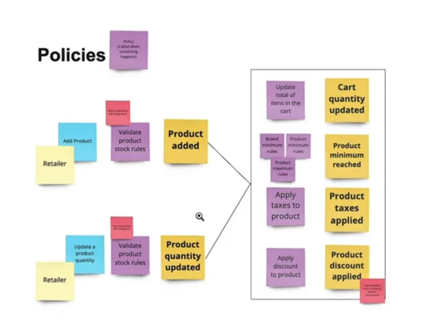

Tactical design

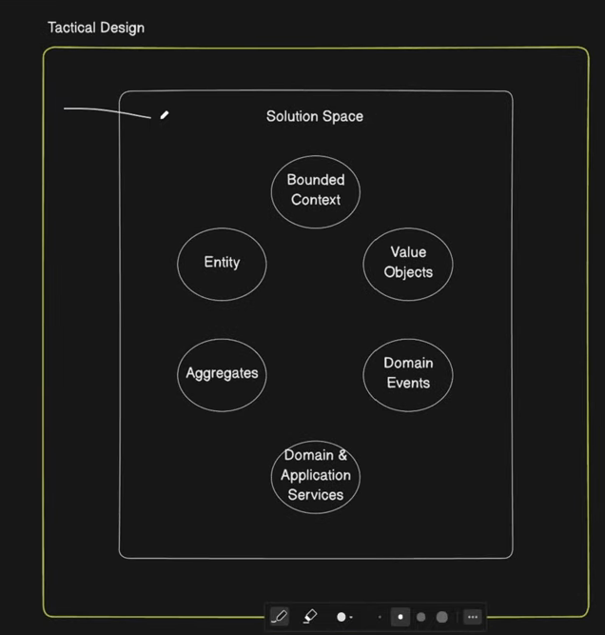

- Solution oriented
- Bounded context
  - Example shipping , payment
- Entity
  - UUID (ex drone , account)
  - May span multiple bounded contexts
  - Attributes may change over time
- Value objects
  - Has not ID , defined by its values
  - Immutable
  - Basic building block of the domain model
- Aggregates
  - Clusters one or more entities into a consistency bondary
  - Has one root entity
  - All other child entities are referenced by the root
  - Usually bound to a transaction scope
- Services
  - Has no state
  - Domain services encapsulates domain logic
  - Applications services – auth , emailing
- Domain events
  - Facilitate async messaging between bounded contexts (or microservices) (ex: Delivery created , Delivery completed)
- Domain & Application Services

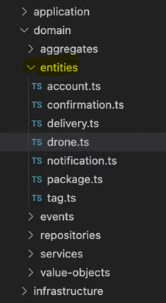

Value objects can be battery level

